**[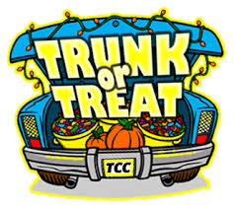](http://www.google.com/imgres?imgurl=http://www.mactionkarate.com/events/halloween/trunkortreat_logo13.jpg&imgrefurl=http://www.mactionkarate.com/events/halloween/&h=295&w=330&tbnid=FfOAy_NmOkZdGM:&zoom=1&docid=cwQAoDI08Uyx3M&ei=xJ4sVP2cJcPxoAT68YGYBQ&tbm=isch&ved=0CD4QMygHMAc&iact=rc&uact=3&dur=576&page=1&start=0&ndsp=29)**

Trunk or treat is coming up again!

**Monday, Oct. 31st. from 6-7:30pm**

in the upper church parking lot. A fun, **FREE** family event! Join us for treats, music, and more.... If you can provide some time and a car trunk we would love for you to help pass out candy. Please sign up with Yasmin Hampton or Rebecca DeBreau so we know who to expect. Also, we need lots & lots of candy.

Thank you in advance for your cooperation.